PLAN 390 Homework 6: Network Analysis

Using the four variables provided i.e., bike_ln, highway, spd_lm, and lanes, I was able to classify the roads into whether there are LST 1, 2, 3 or 4, and I created a map using ArcGIS Pro i.e., Figure 1, showing the links that are LST 1 (Green) and LST 2 (Blue). On the <https://wiki.openstreetmap.org/wiki/Key:highway#Highway> website, I looked at the description and the image provided of the highway type, in order to determine if the link is LST 1, 2, 3, 4. The methodology I used to classify the roads are listed below.

* LST 1

Highway: unclassified, residential, cycleway, footway, living_street, path, pedestrian, track,

Speed limit: less than equal to 25mph ( <= 25)

Lane: 0, 1, 2

Bicycle: yes or no

* LST 2

Highway: primary, primary_link, service

Speed limit: less than equal to 30mph ( <= 30)

Lane: 0, 1, 2, 3

Bicycle: yes or no

(Also includes LST 1)

* LST 3

Highway: trunk, secondary, tertiary

Lane: 0, 1, 2, 3, 4

Speed limit: greater than 30 mph and less than equal to 55 mph ( >30 and <= 55)

Bicycle lane: no

* LST 4

Highway: motorway, motorway_link, secondary_link, trunk_link, tertiary_link

Lane: all

Speed limit: greater than 55mph ( >55)

Bicycle lane: no

Includes: everything that is not LST 1, 2 and 3

On ArcGIS Pro, I opened the shapefile for the road network in Chapel Hill. I clicked on the Map tab, then on Select by Attributes, and in there I was able to write my expression for each LTS and create a layer for them.

To determine which streets are LTS 1, I used the SQL expression:

(highway = 'unclassified' Or highway = 'residential' Or highway = 'cycleway' Or highway = 'footway' Or highway = 'living_street' Or highway = 'path' Or highway = 'pedestrian' Or highway = 'track') And spd_lm_ <= 25 And (lanes = 0 Or lanes = 1 Or lanes = 2)

To determine which streets are LTS 2, I used the expression:

(highway = 'primary' Or highway = 'primary_link' Or highway = 'service') And spd_lm_ <= 30 And (lanes = 0 Or lanes = 1 Or lanes = 2 Or lanes = 3)

Figure 1 shows the levels of traffic stress for LST 1 and LST 2 and Figure 2 shows the same map with street names.

I created a new point layer shapefile to mark the old well. Before doing that, I located the old well on the World Topographic Map in ArcGIS Pro and zoomed in on it. To create the point layer, I went to the View tab, clicked on Catalog Pane, then on Folders, and in Folders, I clicked on my geodatabase file (i.e., file name ending with .gdb), which is where the feature class would be stored. I right clicked on the geodatabase, then went to Feature Class. I named my new Feature class The_Old_Well and set the type of feature class to point, then clicked on Finish. Afterwards, I added the new feature class to my map by dragging and dropping it. I clicked on the feature class and under the Edit tab, I was able to use the tools there to draw a point to mark the old well and saved it. Finally, I combined my LST 1 and LST 2 shapefiles to create one new shapefile, and I imported it and the old well shapefile to QGIS in order to perform the service analysis. Figure 3 shows the service area analysis of the areas within four miles network distance from the Old Well on the LTS 2 (i.e., LST 2 + LST 1). Figure 4 shows the service area analysis of the areas within four miles network distance from the Old Well on the entire Chapel Hill network. Figure 5 shows only the four-mile service areas of the LST 1 and LST 2 and the entire Chapel Hill network. Looking at Figure 5, it can be seen that there is a huge lack of safe cyclist accommodation on many of the roads in Chapel Hill, which limits the ability for many to commute to campus by cycling. The red colored network shows the areas which is safe for cycling, and it is smaller than the orange-colored network, which shows the unsafe areas.

To determine which streets are LST 3, I used the SQL expression:

(highway = 'trunk' Or highway = 'secondary' Or highway = 'tertiary') And (spd_lm_ > 30 And spd_lm_ <= 55) And (lanes = 0 Or lanes = 1 Or lanes = 2 Or lanes = 3 Or lanes = 4) And bike_ln = 'no'

The leftover roads were classified as LST 4.

I grouped the LST 3 and 4 to include streets/roads without any bicycle lanes and looked for the one that is the closest to the Old Well, which is where an additional bike lane could be placed in order to improve cycling connectivity in the town. On my LST 3 shapefile, I found Raleigh Road to be the most suitable. It is within the service area analysis of the areas within four miles network distance from the Old Well on the entire Chapel Hill network. Figure 6 shows the bike lane recommendation. Then, I used the Merge tool (found under Data Management tools) to merge the shapefile containing Raleigh Road portions I obtained from the LST 3 Shapefile and the Shapefile of my LST 2 and LST 1 network combined and exported it to QGIS, where I could draw an additional bicycle path. I drew an additional path, not too far from the old well, and then I did another service area analysis and transported the new shapefile back to ArcGIS Pro. Figure 7 shows a screenshot of my old service area and Figure 8 shows the new one, which includes my improvements. Figure 9 shows the map for the old service area, and Figure 10 shows the map for the new service area. Figure 11 shows a screenshot showing the location of my bicycle path. Figure 12 shows a map comparing the bikeable area using the current LTS 2 network and the bikeable area with my new path and lane highlighted in green.

Extra Credit:

Part 1:

On ArcGIS Pro, I used the shapefile of Orange, Wake and Durham County from assignment 3, which I had the triangle census data table from assignment 3 joined to, the Select by Location tool and the shapefiles of the two service areas I created. I removed the Wake County portion from the Orange, Wake and Durham County shapefile. To use the Select by Location tool, I set the shapefile of Orange, and Durham County (which still has the population demographics data in it) as my input, Insert as the Relationship, and the service area (each one was used at a time) as the Selecting Features. To find how many residents can bike to UNC using low stress routes in under 4 miles on the current network, I right clicked on the total_population column in my attribute table of the Current Service Area Block group shapefile (i.e., that was created from using the Select by Location tool) and clicked on statistics, there I was able to locate the sum. Then, I did the same with the attribute table of New Service Area Block group shapefile I created. Figures 13 shows the service area of the current network and its block groups, and Figure 14 shows the service area of the improved network and its block group.

* Number of residents that can bike to UNC using low stress routes in under 4 miles on the current network (i.e., Service area of LST 2 and 1) = 32,950
* Number of residents that can bike to UNC using low stress routes in under 4 miles on Number of residents that can bike to UNC using low stress routes in under 4 miles on the improved network (i.e., Service area of LST 2 and 1 with new bike lane and path) = 32,950

The numbers of residents are the same because the old and new service areas pass through the same block groups.

Part 2:

In ArcGIS Pro, I opened the orange_durham_parcels shapefile from Sakai. I used the Select by Location tool again and set the orange_durham_parcels shapefile as my input, Insert as the Relationship, and my Bicycle Path shapefile as the Selecting Features. My proposed bike path passes through two parcels. The bike path passes right through the middle. Figure 15 shows my bike path and parcel boundaries.

Figures

**Figure 1.** Stress Map showing only LST 1 (Green) and LST 2 (Blue) links in Chapel Hill

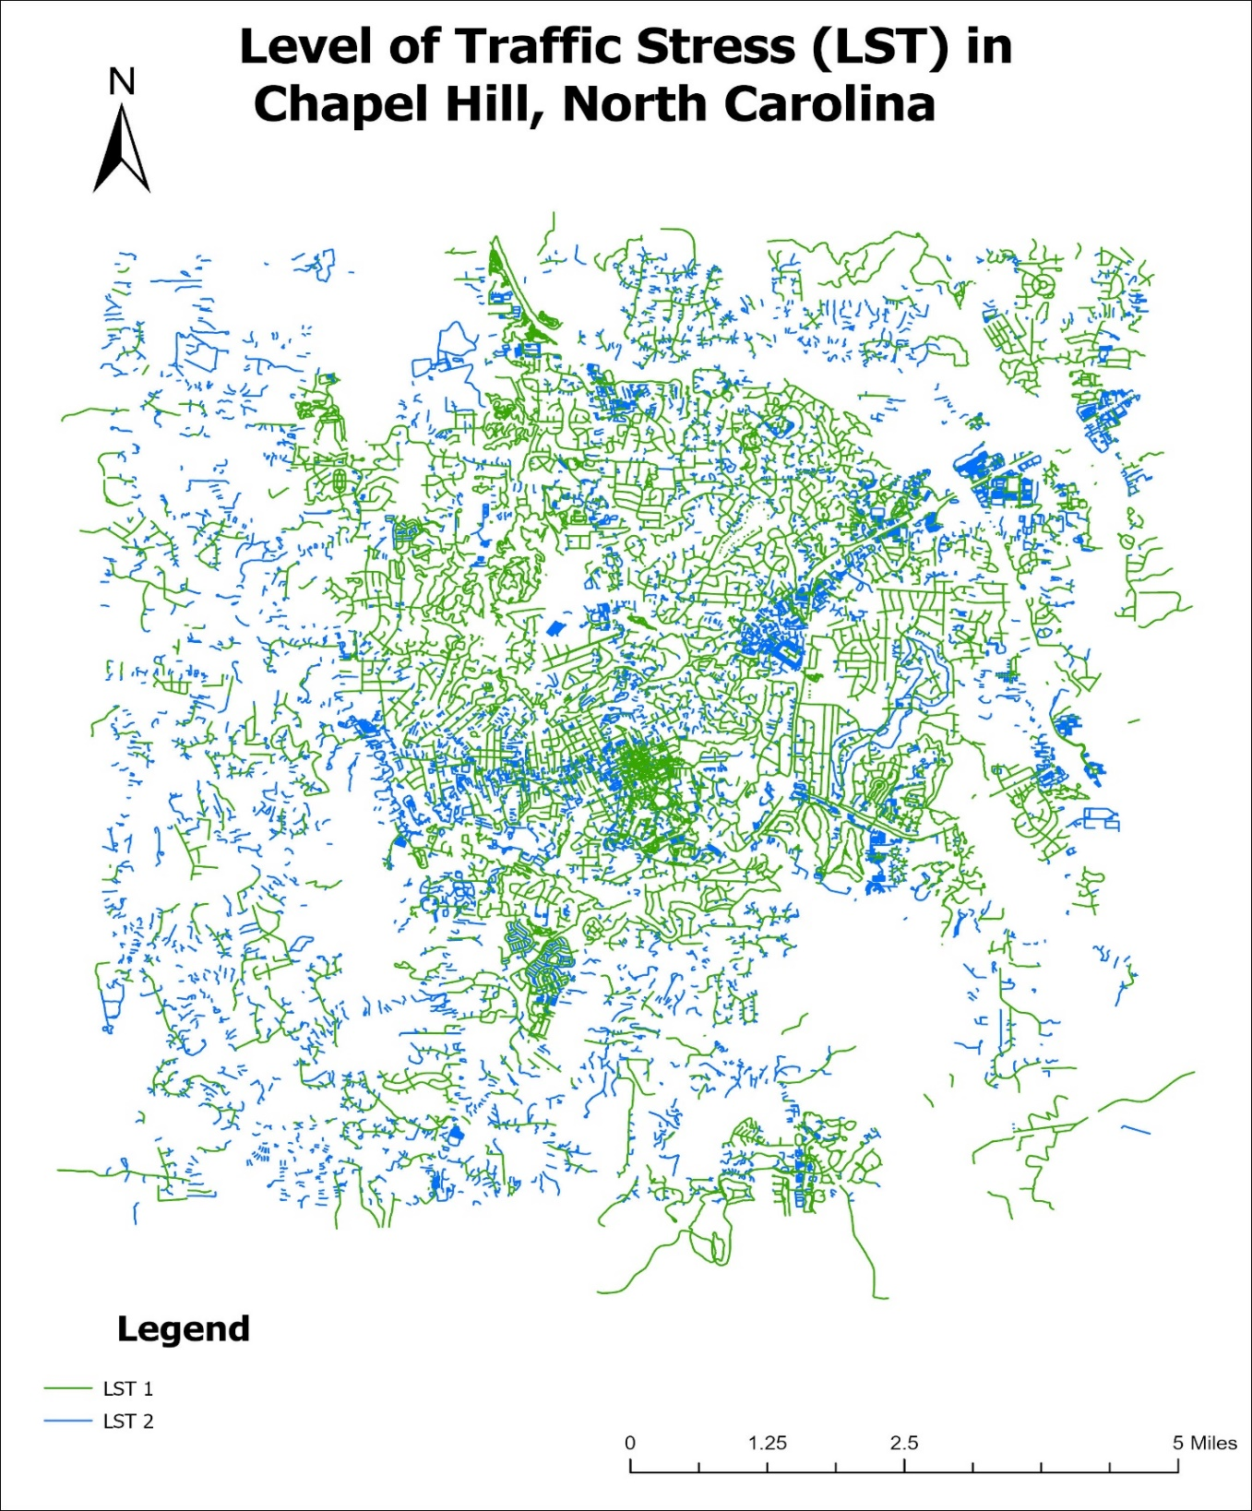

**Figure 2.** Stress Map with Street Names showing only LST 1 (Green) and LST 2 (Blue) links in Chapel Hill

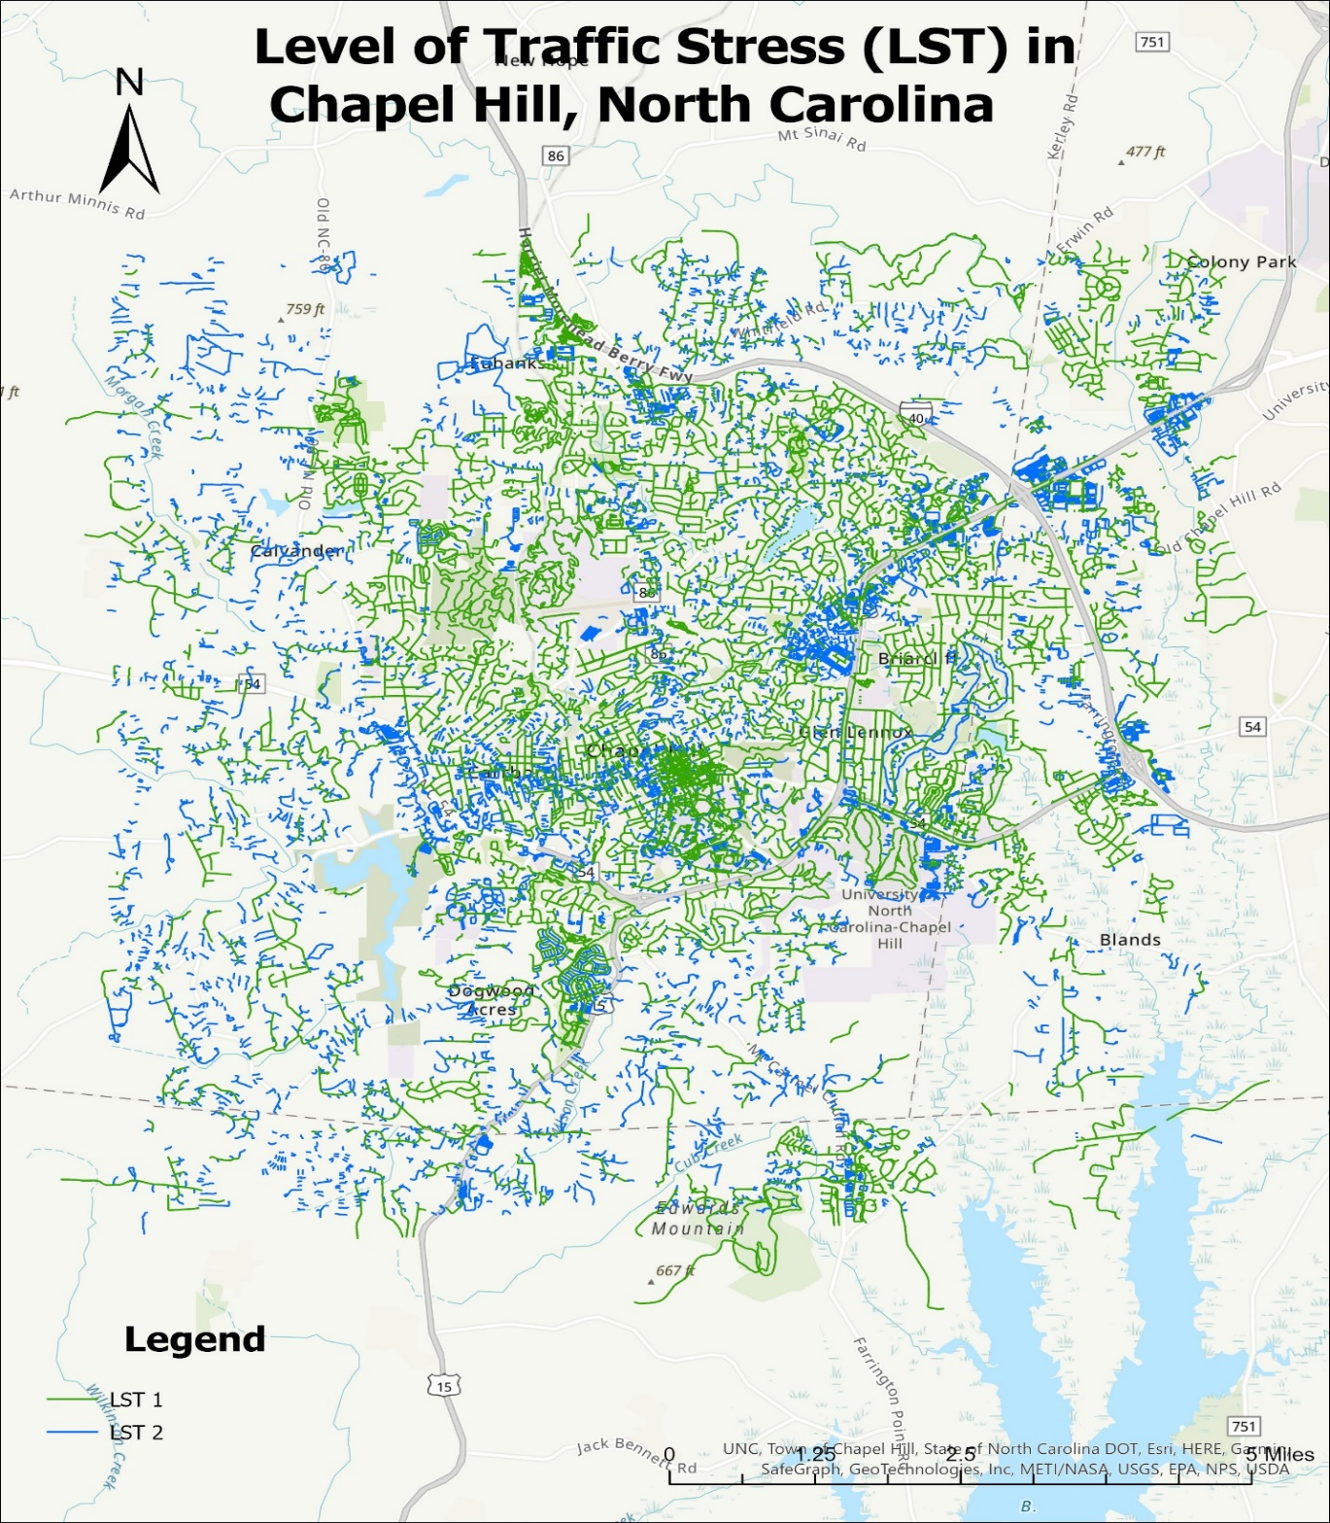

**Figure 3.** Service area analysis of the areas within four miles network distance from the Old Well on LST 2 and LST 1

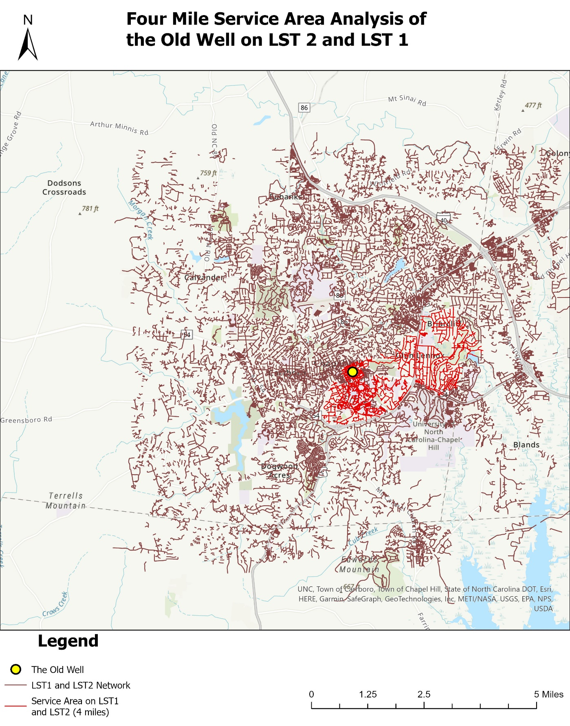

**Figure 4.** Service area analysis of the areas within four miles network distance from the Old Well on the entire Chapel Hill Network

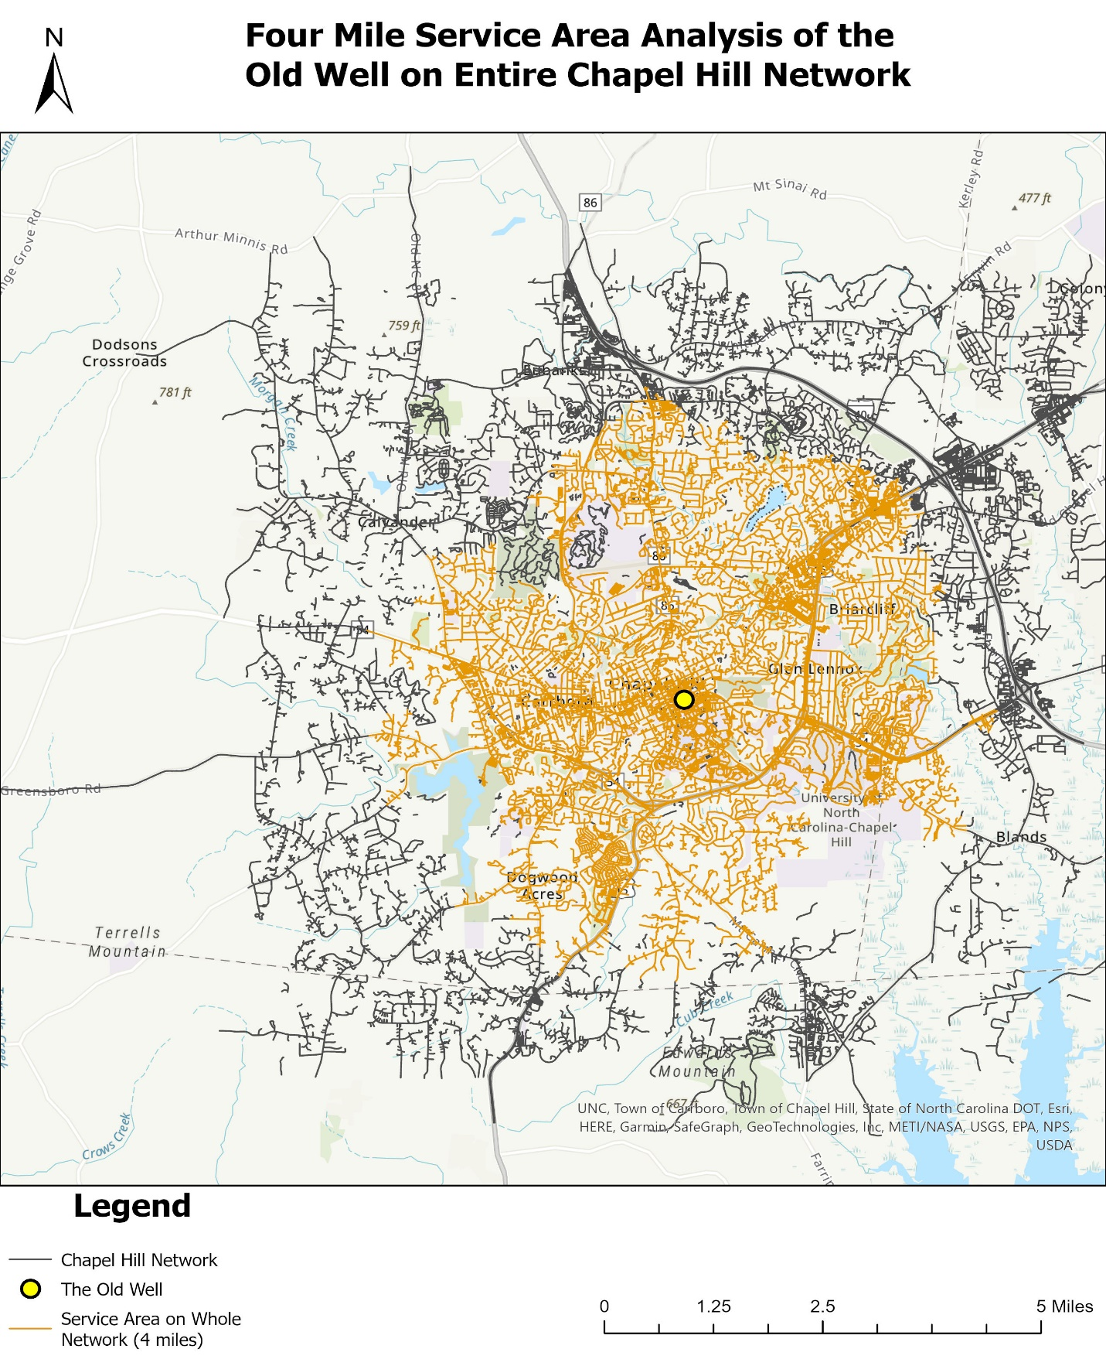

**Figure 5.** Service area analysis of the areas within four miles network distance from the Old Well on LST 2 and LST 1and the entire Chapel Hill network

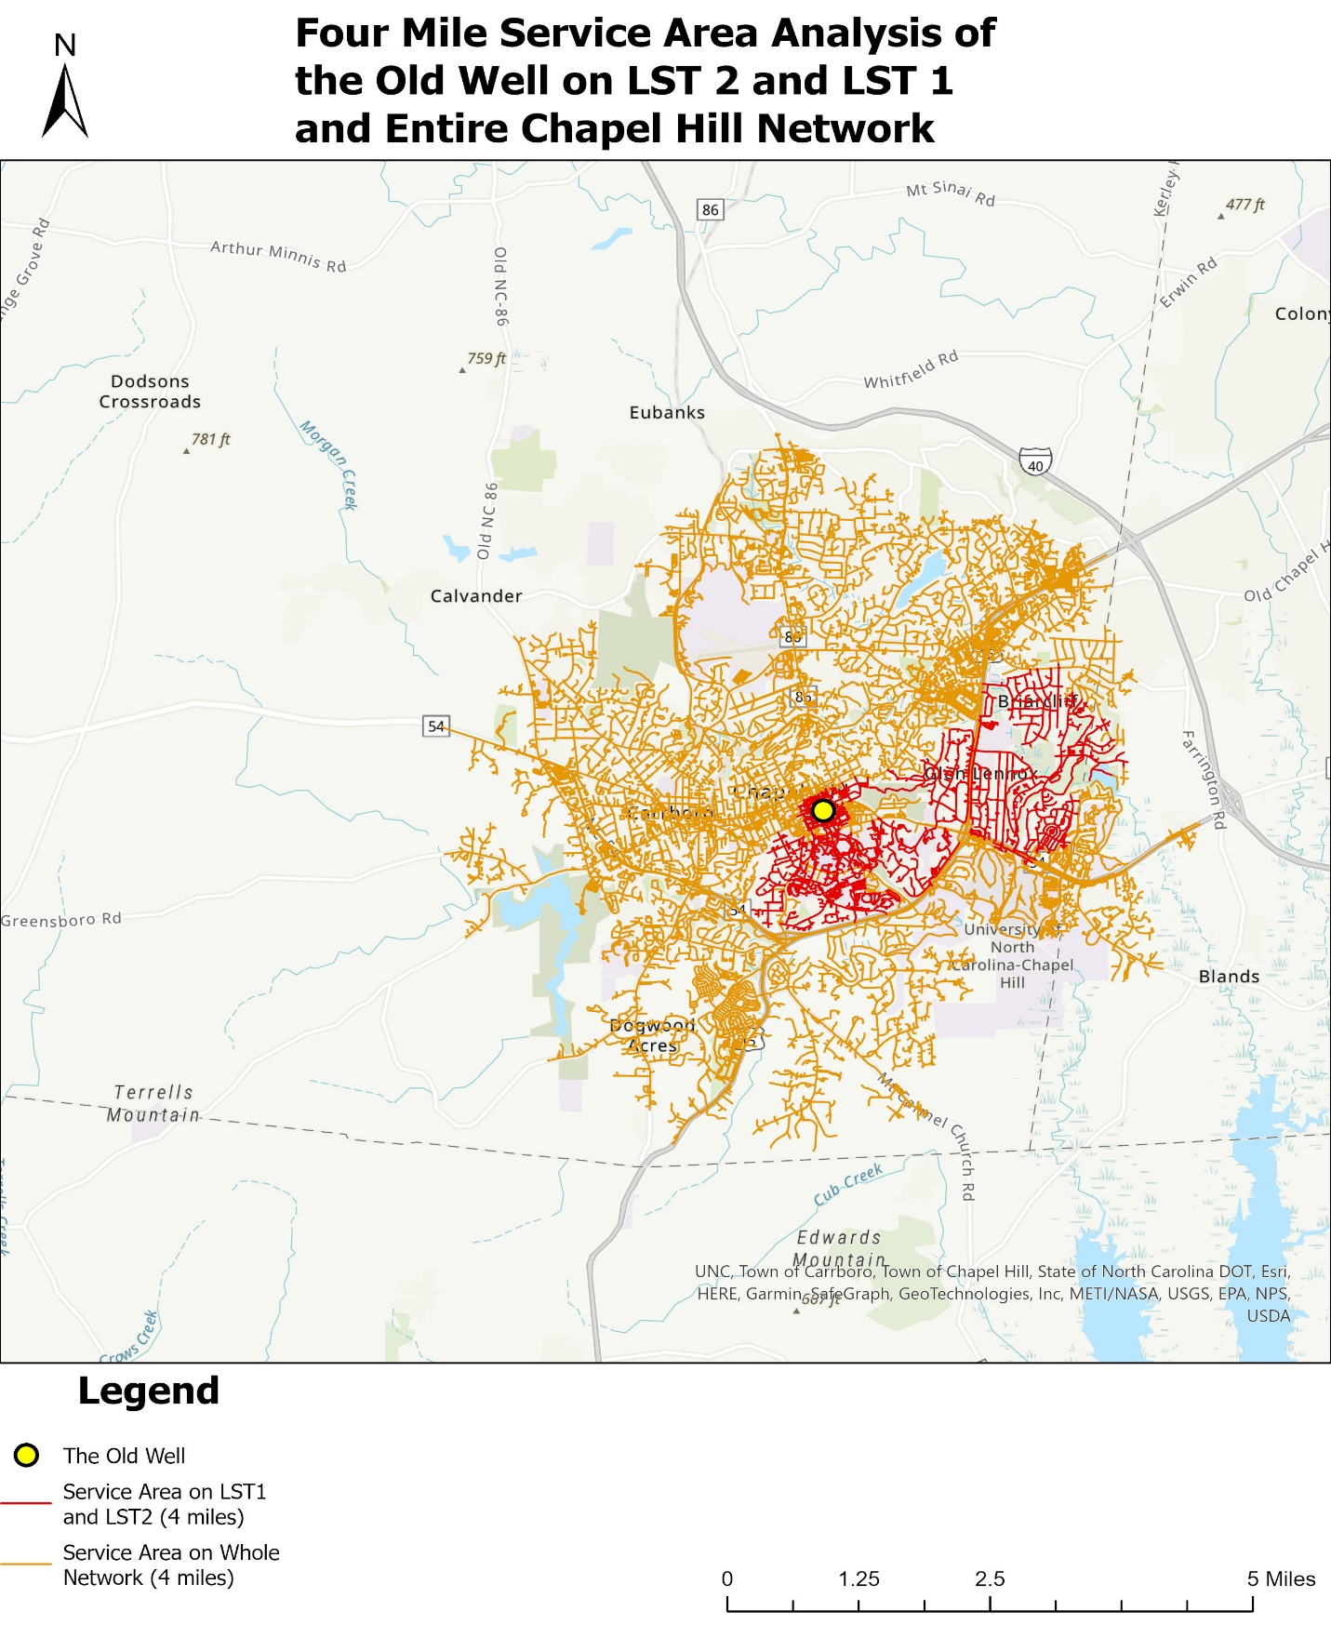

**Figure 6.** Map showing bike lane recommendation.

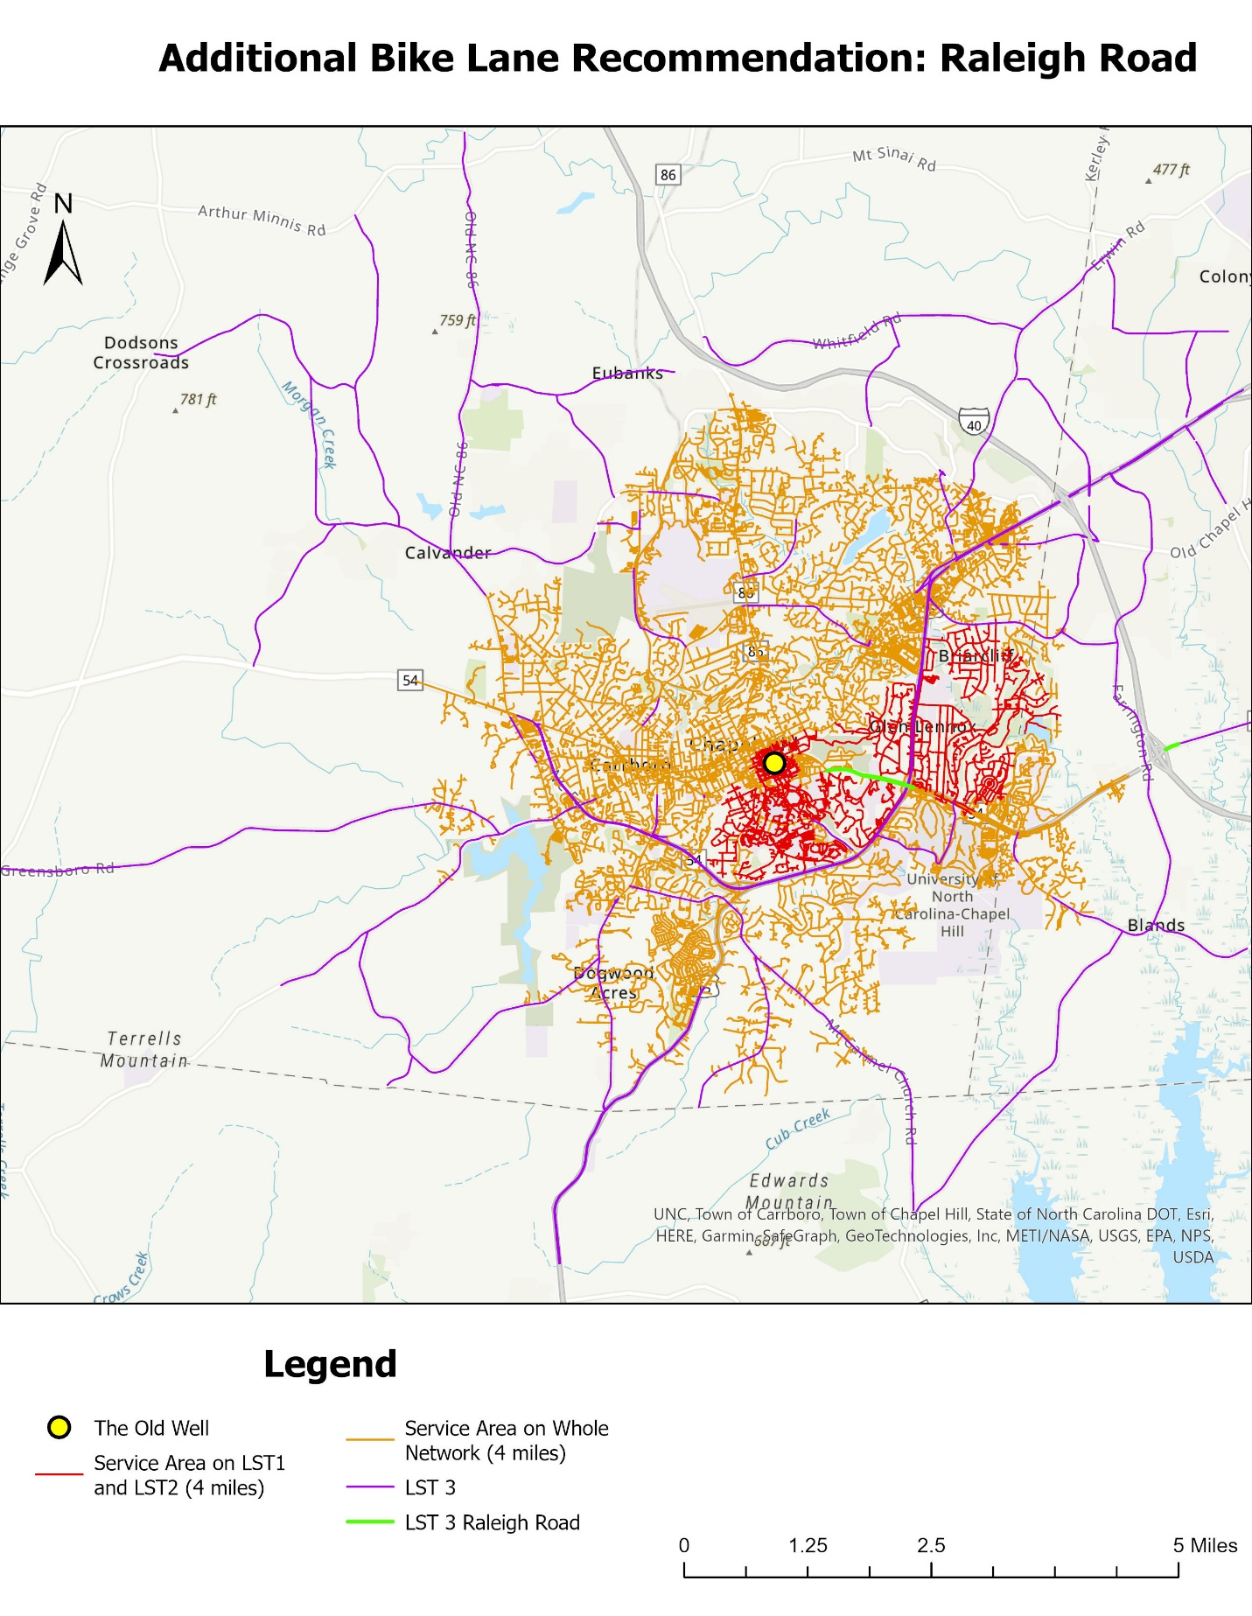

**Figure 7.** Screenshot of First 4-mile Service Area Analysis for LST 2 and LST 1 Combined

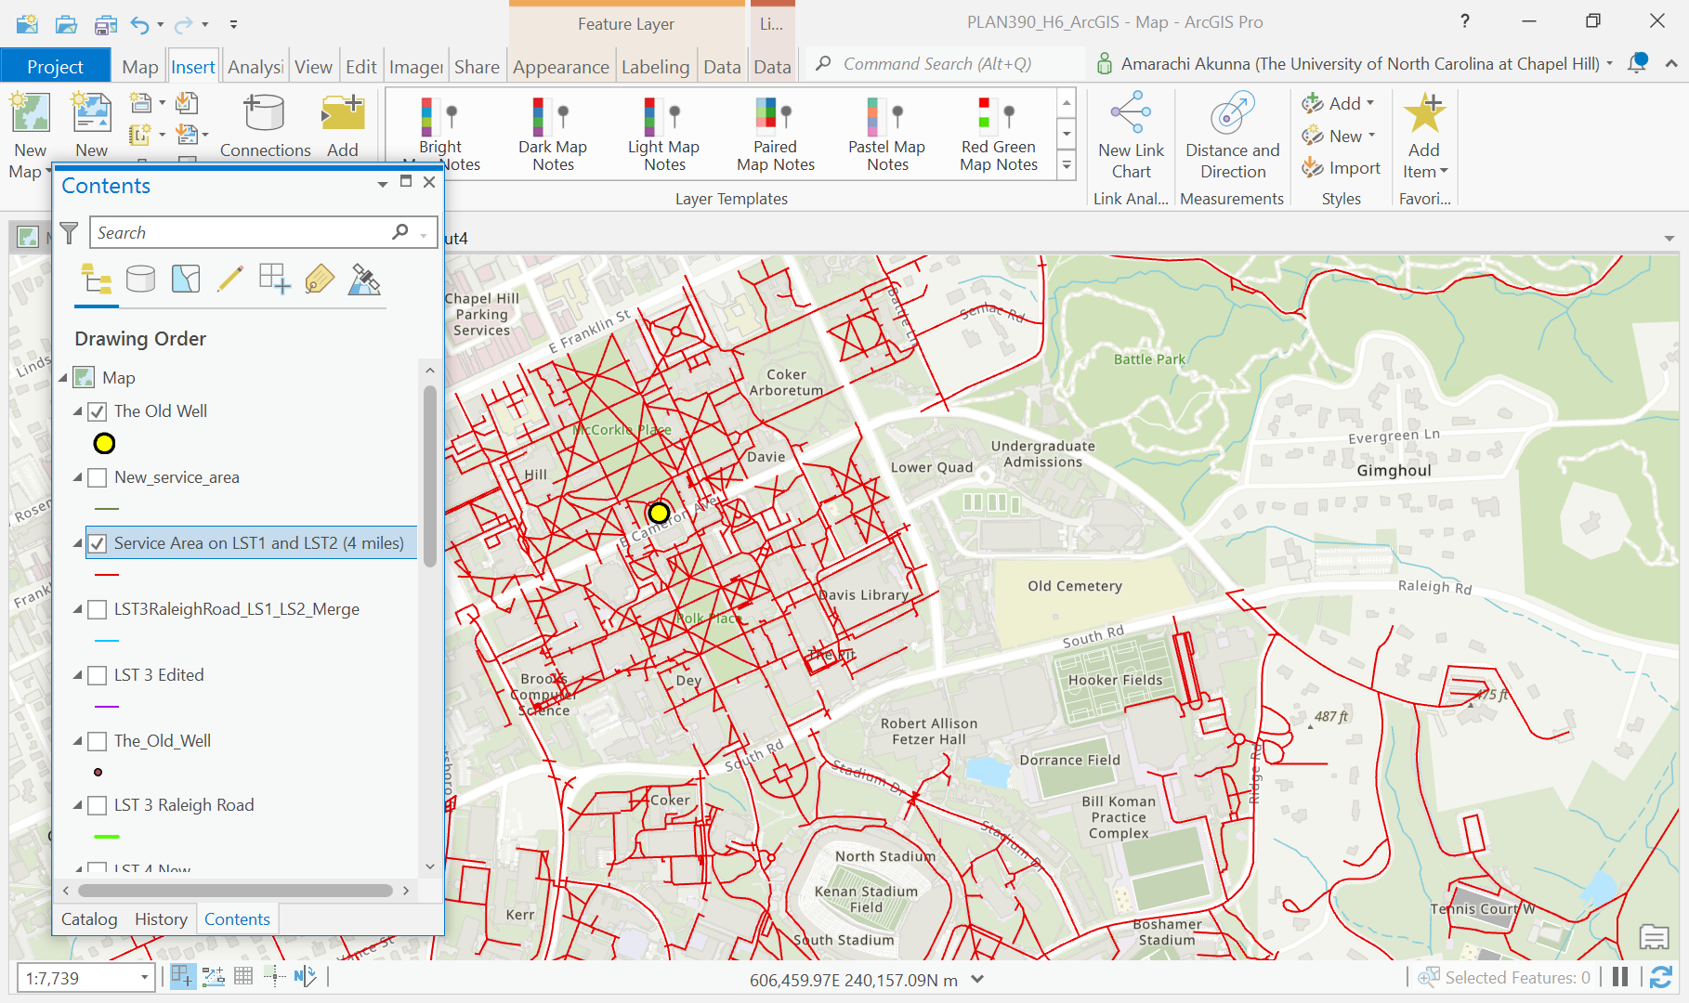

**Figure 8.** Screenshot of Second 4-mile Service Area Analysis for LST 2 and LST 1 Combined with Bicycle Lane and Path Added

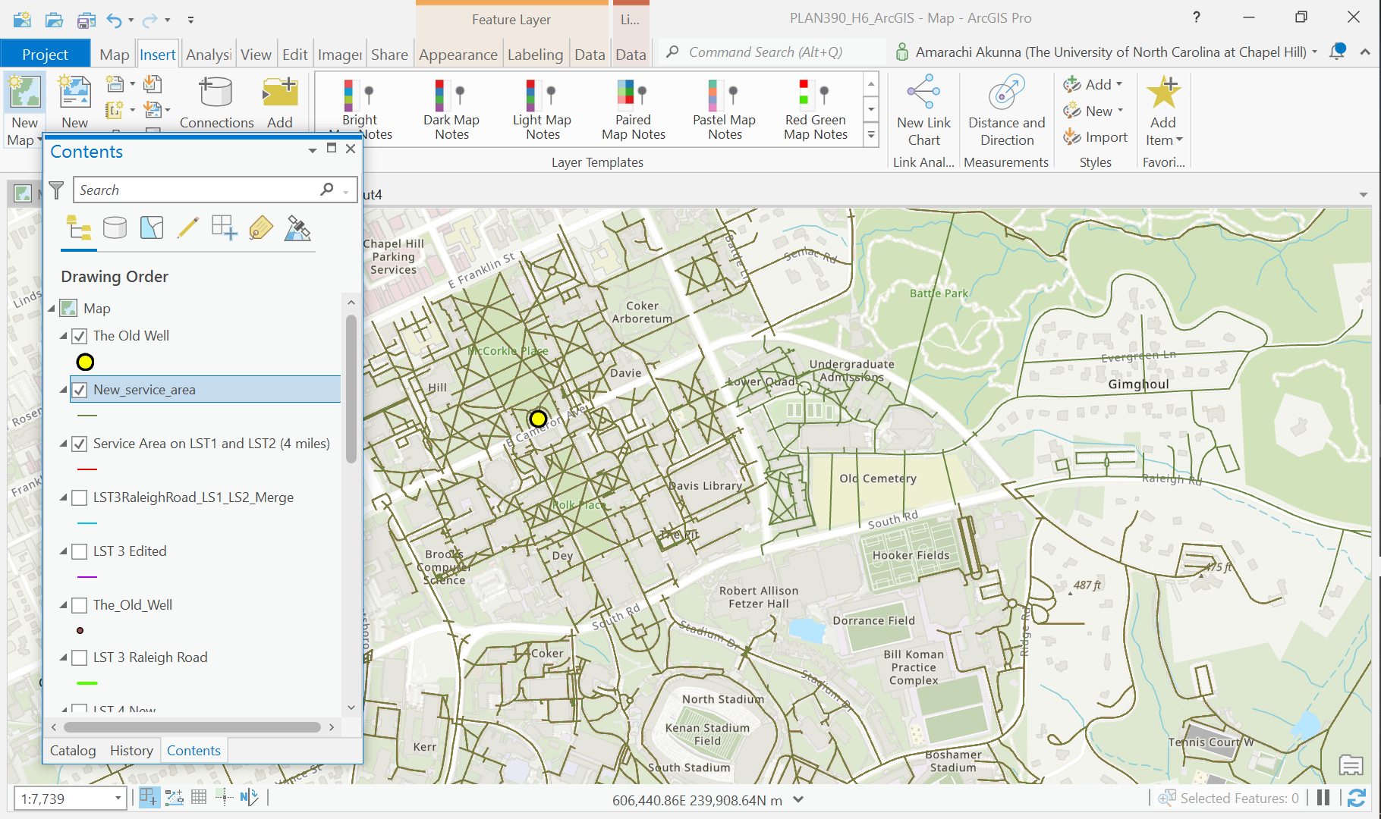

**Figure 9.** Map of First 4-mile Service Area Analysis for LST 2 and LST 1 Combined

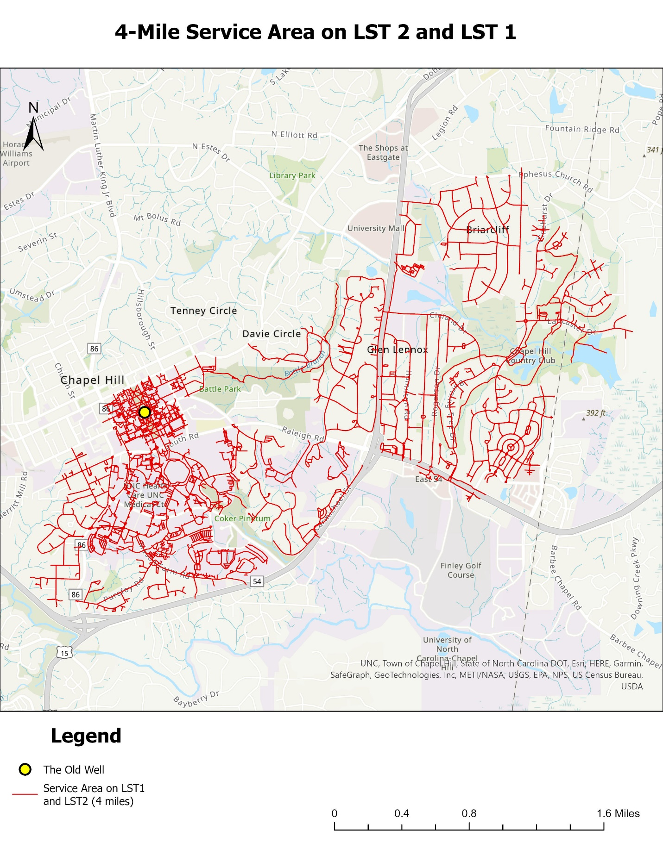

**Figure 10.** Map of Second 4-mile Service Area Analysis for LST 2 and LST 1 Combined with Bicycle Lane and Path Added

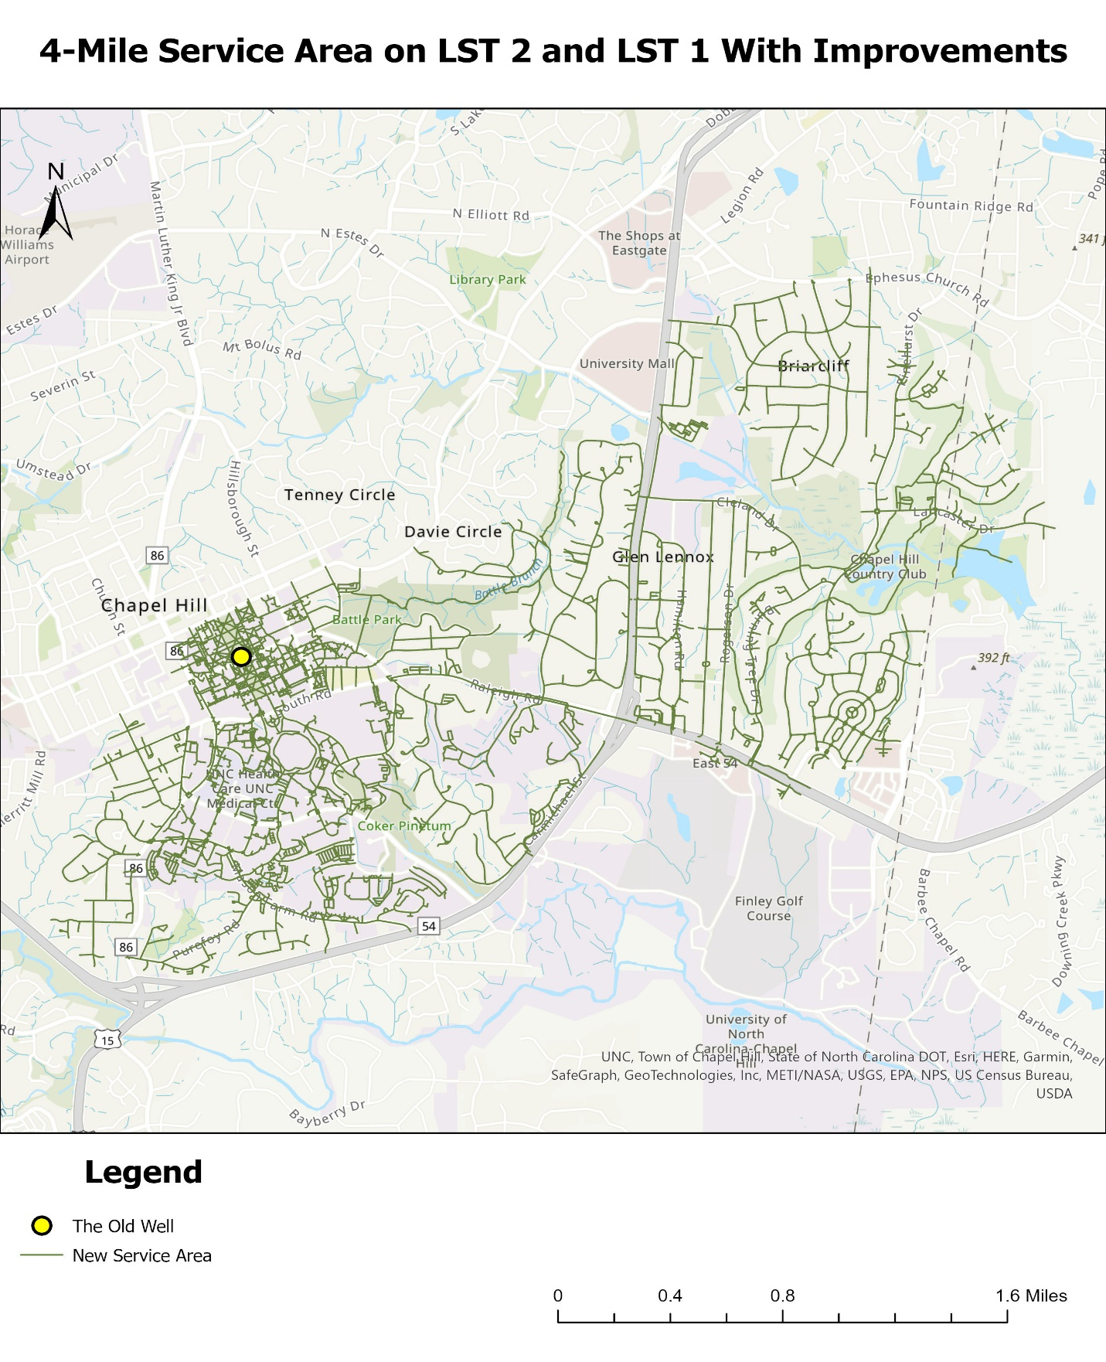

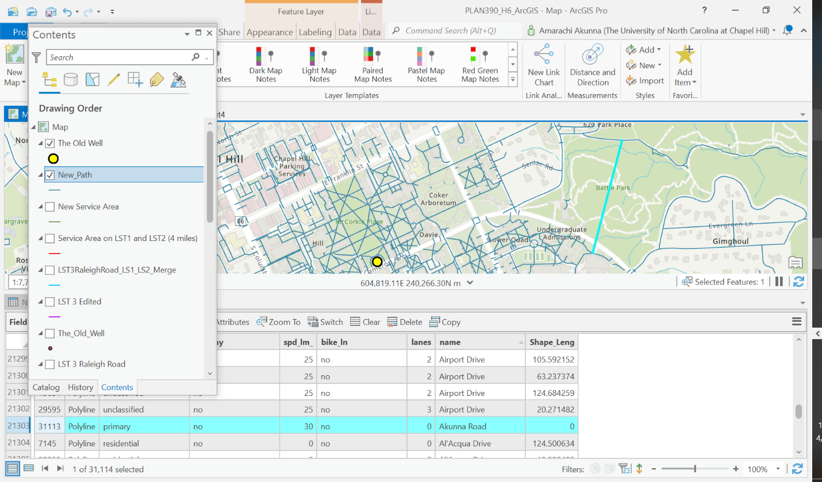**Figure 11.** Screenshot showing the location of my bicycle path.

**Figure 12.** Map of Second 4-mile Service Area Analysis for LST 2 and LST 1 Combined with Bicycle Lane and Path Added (Highlighted in Green)

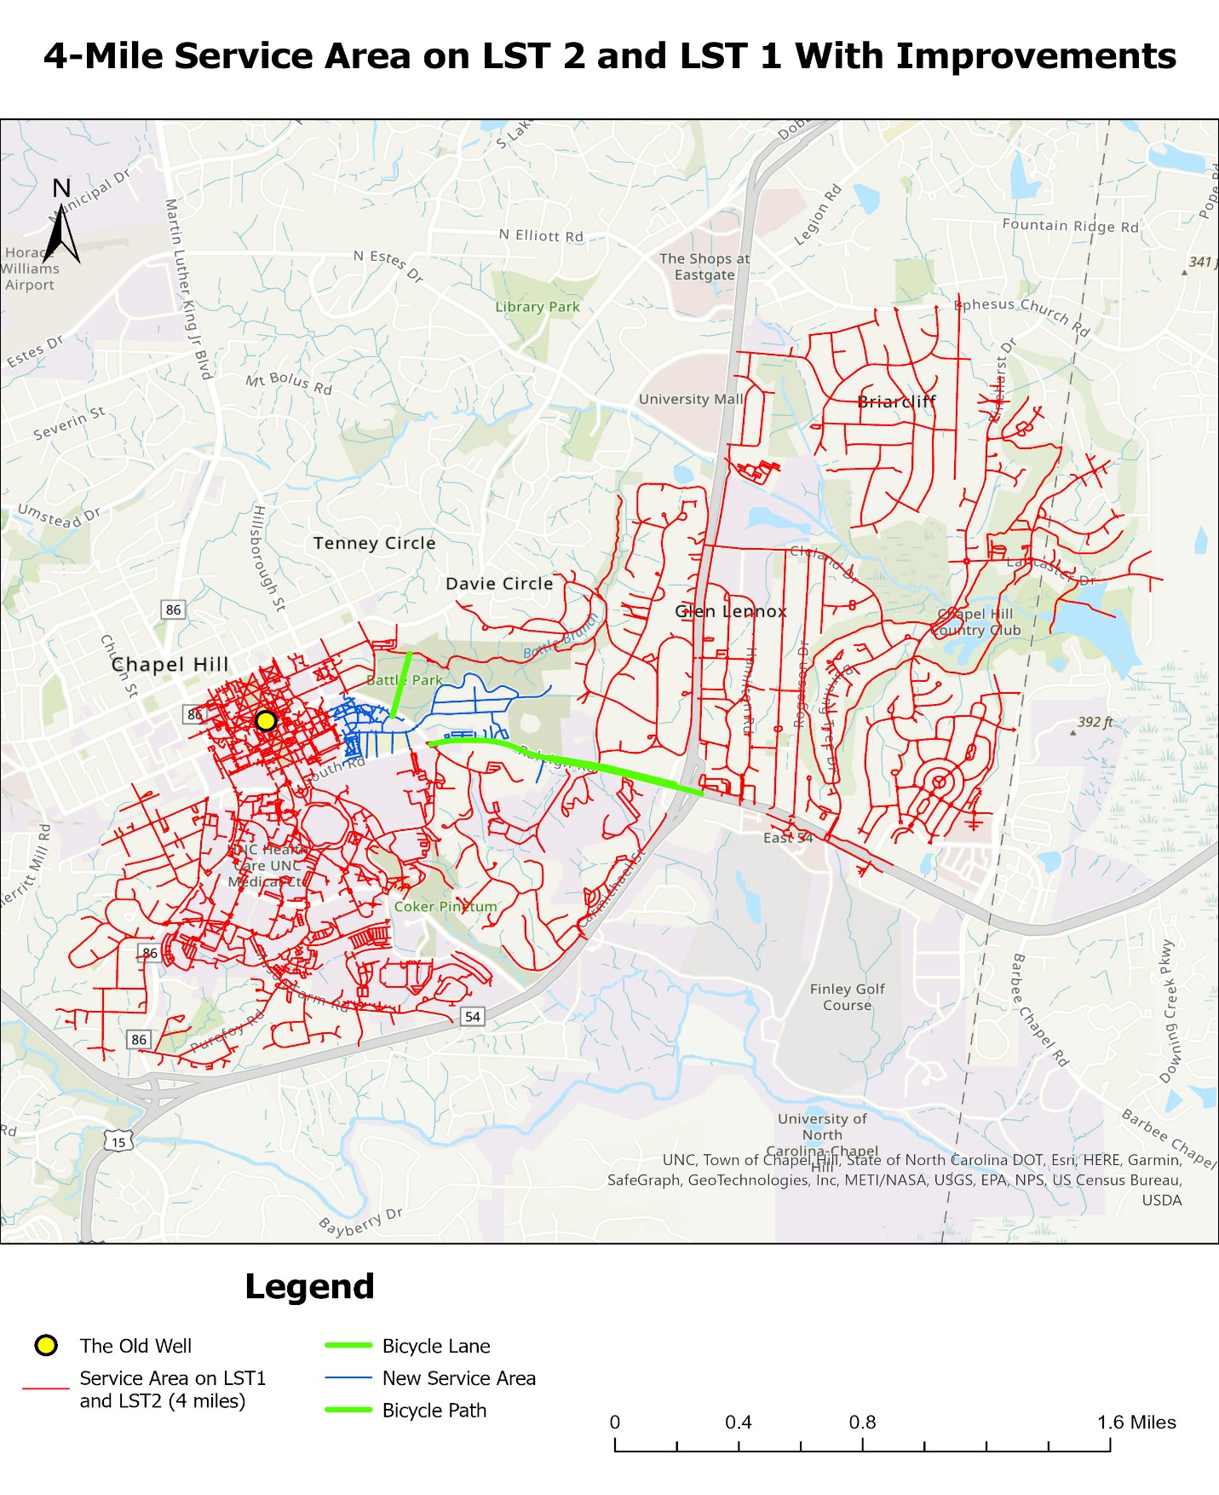

**Figures 13.** Service Area of the Current network and Its Block Groups

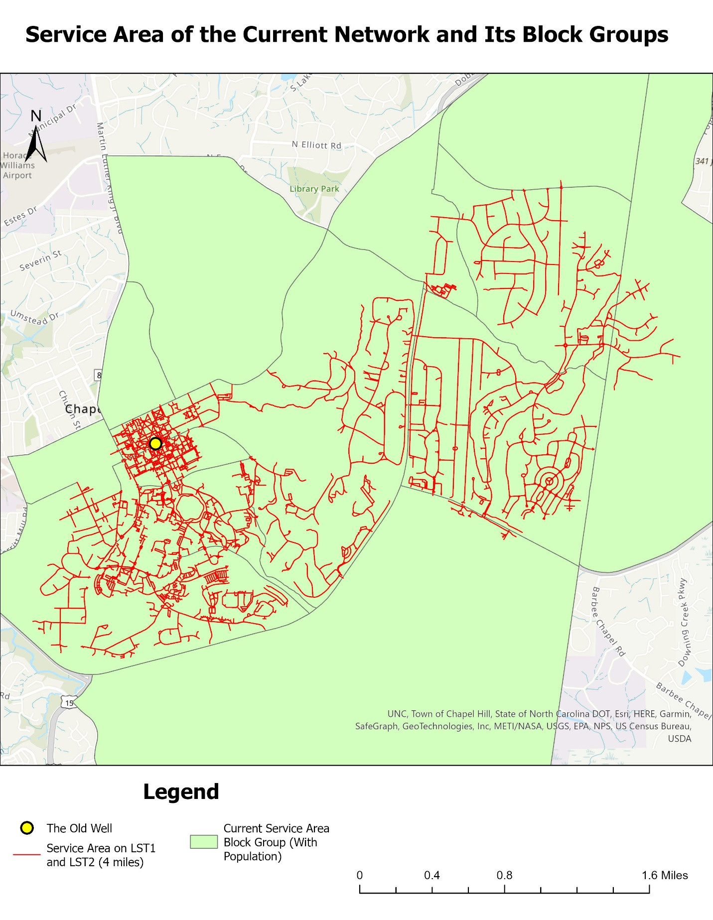

**Figure 14.** Service Area of the Improved Network and Its Block Groups

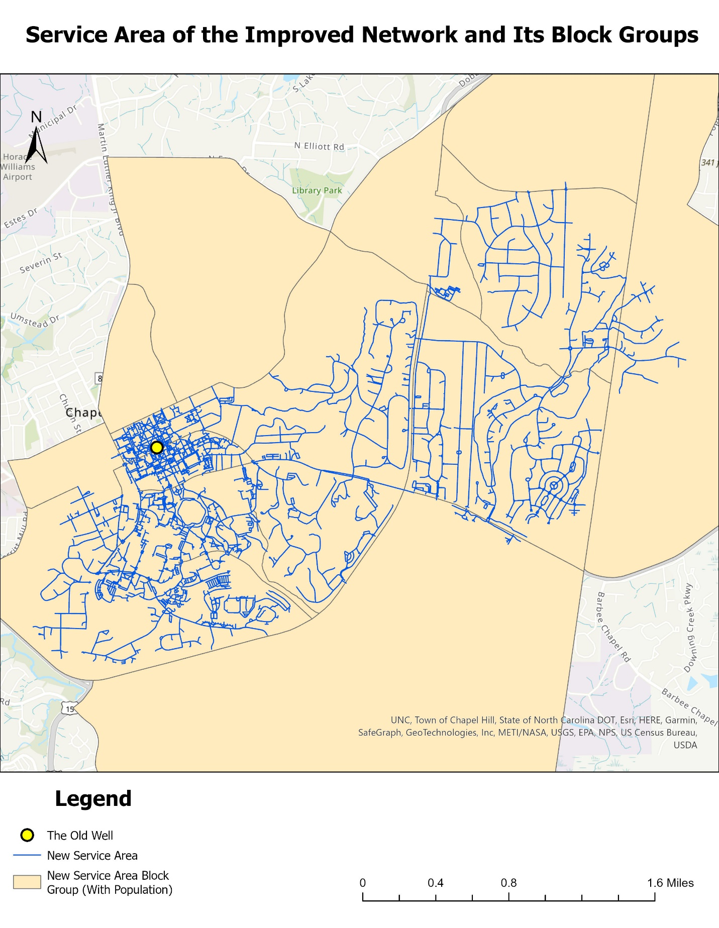

**Figure 15.** Map showing my bike path and parcel boundaries

